SC Server and Database Queries Overview

- SC Servers:

10.4.1.31 - Database (DB) Server
DB Name: VMWSC.Digital DB
DB user: SA
DB password: P#ssw-rd098.

10.4.1.29 - SC Application Server 1:
Server username: administrator
Server password: P#ssw-rd098
Physical Path: C:\Leading-Point\SCAPI.Digital.

10.4.1.23 - SC Application Server 2:
Server username: administrator
Server password: P#ssw-rd098
Physical Path: C:\Leading-Point\SCAPI.Digital.

- The API on SC:
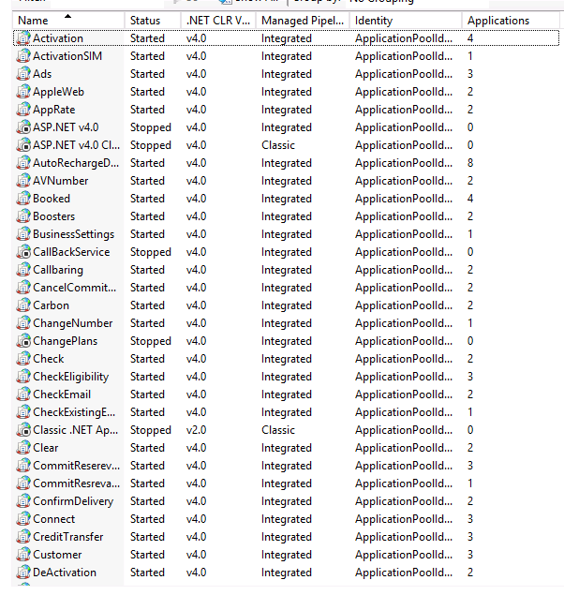
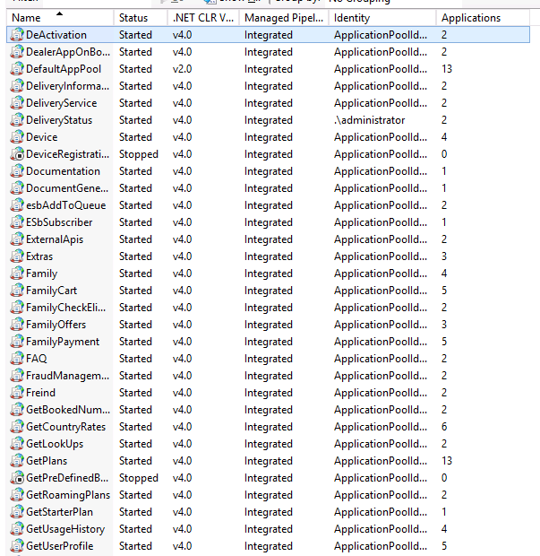

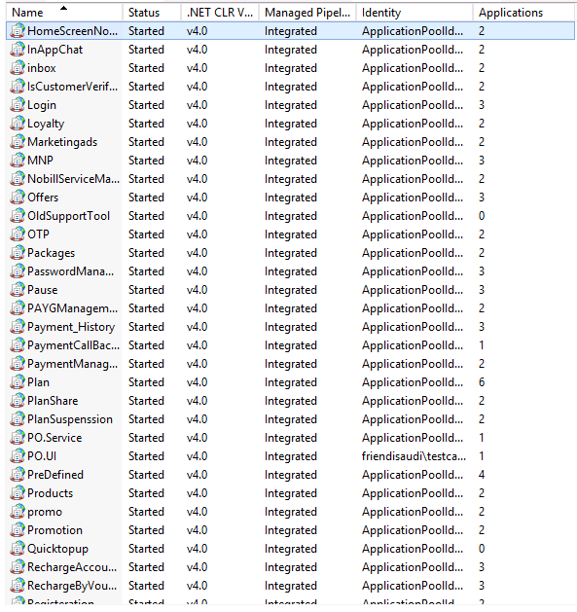
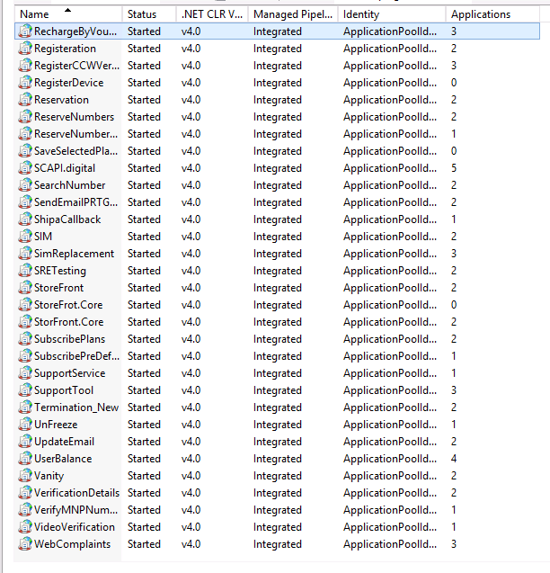

- SC Database Queries and Their Purpose

1. Check Booked Numbers Status:

SELECT * FROM Booked_Numbers WHERE BookedNumber = '' ORDER BY 1 DESC;
SELECT * FROM Booked_Numbers WHERE regid = '' ORDER BY 1 DESC;
SELECT * FROM Booked_Numbers WHERE email = '' ORDER BY 1 DESC;

Purpose: These queries retrieve information about the status of booked numbers.
Key Status:

ReservationStatus = 1: The customer reserved the number but has not paid.
ReservationStatus = 3: The customer has reserved and paid for the number.
If BookingStatus = 1: The customer activated the number.
If BookingStatus = 0: The customer has paid but the number is still not active.
ReservationStatus=4:The customer cancel the reservation.
ReservationStatus=5:The auto cancel cancel the reservation based on expiry date.

2. Check Customer Registration Status

SELECT * FROM Registration WHERE Email = '';
SELECT * FROM Registration WHERE id = '';

Purpose: To verify if a customer’s account is active and retrieve their information, including the customer ID.

3. Check User Plan

SELECT * FROM UserSelectedPlan WHERE RegId = '';
SELECT * FROM UserSelectedPlan WHERE bookednumberid = '';

Purpose: To verify the user’s selected plan and ensure it is correctly linked to the payment ID and booked number ID.

4. Check Payment Status

SELECT * FROM servicepayment WHERE regid = '' ORDER BY 1 DESC;
SELECT * FROM servicepayment WHERE id = '';
SELECT * FROM servicepayment WHERE MSISDN = '' ORDER BY 1 DESC;

Purpose: To check the payment status of a customer, including whether the payment is confirmed.

5. Check Customer API Log

SELECT * FROM MethodTrace WITH (NOLOCK) WHERE regid = '' ORDER BY 1 DESC;

Purpose: To review the log of APIs the customer has called from the app. This helps in diagnosing issues with the API, tracking responses, and monitoring processing times.

6. Check API Exceptions

SELECT * FROM LOG WITH (NOLOCK) WHERE regid = '' ORDER BY 1 DESC;

Purpose: To identify any exceptions encountered by the API for a specific customer or general API-related exceptions.

